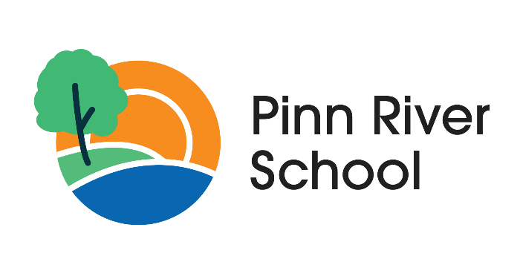

Anti-Bullying Policy

Category: | Behaviour
Authorised By: | Director for Schools
Signature: | 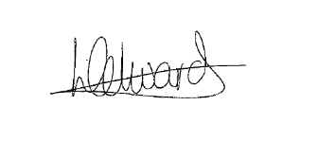
Signed By: | Liz Edwards
Author: | Nicola Witts
Version: | 2.0
Status: | Ratified
Issue Date: | June 2025
Next Review Date: | June 2026

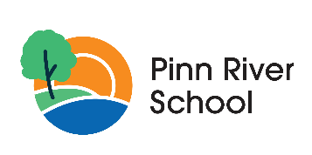

Pinn River School
Anti-Bullying Policy June 2023

- Statement of Intent
Pinn River School is committed to providing a safe and inclusive environment for all students, regardless of their abilities. We recognize that students with severe learning difficulties may struggle to understand the concept of bullying and may unintentionally engage in behaviours that could be considered bullying. As such, we have developed this anti-bullying policy to help prevent and address any incidents of bullying that may occur within our school community.

- What Is Bullying?
Bullying is defined as any repeated aggressive behaviour that is intentional and involves an imbalance of power or strength.
This can include physical, verbal, or social aggression.
Bullying can also include cyberbullying, which is the use of technology to harass, humiliate, or harm others.
Bullying can be:
- Emotional: being unfriendly, excluding, tormenting (e.g. threatening gestures)
- Physical: pushing, kicking, hitting, punching or any use of violence • Racist: taunts, graffiti, gestures
- Sexual: unwanted physical contact or sexually abusive comments
- Homophobic behaviour
- Verbal: name-calling, sarcasm, spreading rumours, teasing
- Cyber: All areas of internet, such as email & internet chat room misuse, mobile threats by text messaging & calls, misuse of associated technology , i.e. camera & video facilities

- Objectives of this Policy
All teaching and non-teaching staff, LAB members, students and parents should have an understanding of what bullying is. All teaching and non-teaching staff, LAB members, students and parents should know what the school policy is on bullying and follow it when bullying is reported. All students and parents should know what the school policy is on bullying, and what they should do if bullying arises. Students and parents should be assured that they will be supported when bullying is reported.

- Why is it Important to Respond to Bullying?
Everybody has the right to be treated with respect. In addition, students who are exhibiting bullying behaviour need to learn different ways of behaving. We have a responsibility to respond promptly and effectively to issues of bullying

- The responsibilities of the Headteacher and Trustees are:

- Ensuring staff receive appropriate training in disability equality, and how to recognise and deal with bullying
- Developing a system of recording incidents of bullying
- Determining and ensuring the implementation of a policy for the pastoral care and support for learners
- Celebrating the anti-bullying work of the school
- Ensuring ‘pupil voice’ policies enable the school to capture all aspects of their learners’ communications, including behaviour-related information (in conjunction with SEL Policy)
- Providing structures and systems that respond effectively to the ‘pupil voice’, so that the views of learners are known to be significant
- Demonstrating and acknowledging a range of success measures, beyond those of the academic achievement traditionally valued by schools, so that all learners feel valued.
- All staff will receive training on how to recognize and prevent bullying
- All students will receive age-appropriate education on what constitutes as bullying and how to report it.
- All students will receive education on how to be an ally and how to support their peers in a respectful manner.
- Regular assemblies will be held to reinforce our school's stance against bullying and the importance of inclusion and respect.

- The responsibilities for teachers and support staff
Teachers and support staff should ensure that all students feel secure and valued and consequently are able to learn and contribute to school life. Among the ways teachers can achieve this are by:
- Promoting the well-being of individual students and ensuring, as far as possible, that students are free from bullying and harassment
- Ensuring that students who have experienced bullying are taken seriously
- Helping students to take responsibility for their actions
- Helping students to take a positive view of difference and challenging stereotypical views • Celebrating the successes of disabled students
- Helping students to articulate their views and experiences
- Modelling the behaviour and values of the school to all students
- Taking advantage of training opportunities to increase their understanding of disability and improve their ability to recognise bullying and support behaviour
- Providing well-differentiated and accessible learning opportunities so that all students experience the self-esteem and confidence that comes with success and achievement.

- The role of Parents/Carers:
Parents/Carers are the experts on their child’s behaviour and their physical and mental well-being. They have a key role to play in supporting their child if they bully others or experience bullying themselves. They can offer advice to school staff on extra support their child might need or any creative solutions that may help to resolve conflict.
Parents/Carers have a wealth of knowledge that the school will want to call upon when developing or reviewing this anti-bullying policy. It is important that as a school we listen to and respond to parents' concerns and keep good communication going between them when dealing with bullying incidents relating to their child.

- Preventing of bullying is crucial and is helped by:
- Effective school leadership that promotes an open and honest anti-bullying ethos
- Use of curriculum opportunities (in particular, PSHE can be used to discuss issues around diversity and draw out anti-bullying messages).
- A whole-curriculum approach to developing social and emotional skills in areas such as empathy and the management of feelings, is also highly relevant to reducing bullying.
- Engaging pupils in the process of developing the school anti-bullying policy and promoting open and honest reporting.
- Developing class and school rules together with pupils that clearly emphasise an anti-bullying message.
- Improving the school environment and ensuring that pupils feel a sense of self-worth and esteem. Displays and messages around the school that promote an anti-bullying message. The creation of a positive school ethos is therefore crucial in the prevention of bullying. In spite of our best efforts, there may still be occasions when bullying occurs.

- Reporting
Any student or staff member who witnesses or experiences bullying should report it immediately to a teacher, keystage leader or senior leader. All reports will be taken seriously and investigated promptly. Reports can be made anonymously, but this may make it more difficult to fully investigate and address the incident.

- Procedures
- Report bullying incidents to teacher, keystage lead or senior leader
- Incidents will be recorded by staff on Behaviour Watch
- In serious cases parents should be informed and will be asked to come into a meeting to discuss the concern
- The bullying behaviour or threats of bullying must be investigated and the bullying stopped quickly
- Behaviour plans will be implemented to help the bully/bullies change their behaviour
- The relevant therapy teams will be called upon to support the bullied individual and provide input for the person who is carrying out the bullying

The success of the interventions will be closely monitored and evaluated by the Head and the Multi-Professional Team (MPT) and will remain in place (or altered where necessary) until the HOS and MPT jointly agree that the interventions have been successful

- Consequences
Consequences for bullying will be determined based on the severity and frequency of the behaviour.
In cases where a student with severe learning difficulties is found to have engaged in bullying behaviour, additional support and education will be provided to help them understand and change their behaviour.
- Possible bullying incident seen or reported to staff member Bespoke package of support is devised Parents are informed of the incident and invited for a meeting if appropriate. MPT notified Incident recorded in full on Behaviour Watch
- Support put in place for victim and the bully using therapy team where appropriate
- Discussion takes place with HT or senior member of staff
- Behaviour plans put in place Monitoring & evaluation of behaviour is carried out Incident is defined as bullying Situation reviewed by Headteacher & MPT until formally agreed sign off

- Cyber Bullying
Due to the nature of the pupils at Pinn River School, it is not anticipated that cyber bullying will be a significant concern. However, it is important that staff are trained and alert to its existence so that they can respond accordingly if and when it occurs.

In the case of cyber bullying, the process described above will be implemented in the same way.
E-safety training for staff takes place annually and as part of the induction process for new staff

