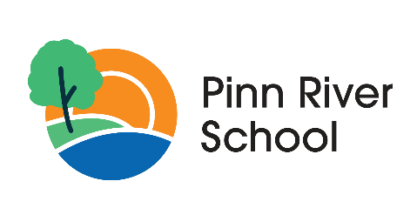

EAL Policy

Category: | School policy
Authorised By: | Andrew Sanders, Regional Director
Author: | Liz Edwards, Headteacher
Owner: | Liz Edwards, Headteacher
Version: | 1
Status: | Approved by The Regional Director under the Trust’s policy management arrangements and scheme of delegtion.
Issue Date: | September 2025
Next Review Date: | September 2026

Version Control

Ver. | Date | Comment
1 | September 2025 | Initial policy.

This policy will be subject to ongoing review and may be amended prior to the scheduled date of the next review in order to reflect changes in legislation, statutory guidance, or best practice (where appropriate).
Contents
1. Introduction 4
2. Statement of aims and commitment 4
3. Identification and assessment 4
4. Support for EAL learners 4
5. Support for parents/carers 4
6. Staff training and development 5
7. Monitoring, review and evaluation of the policy 5
8. Linked policies 5

Introduction
EAL learners are defined by the DfE as ‘A pupil is recorded to have English as an additional language if they are exposed to a language at home that is known or believed to be other than English. This measure is not a measure of English language proficiency or a good proxy for recent immigration.’ (DfE Schools, Pupils and their Characteristics July 2020)
Grand Union Village School (the school) is committed to ensuring that all learners, including those for whom English is an additional language (EAL), have equitable access to education, communication, and support. We also recognise the importance of engaging and supporting parents and carers who do not speak English, ensuring they are fully included in their child’s educational journey.

Statement of aims and commitment
- To support our EAL learners, who will also have special educational needs and disabilities, in accessing the curriculum and developing communication skills.
- To ensure that language is not a barrier to learning, inclusion, or wellbeing.
- To provide accessible communication and engagement for parents/carers who do not speak English.

Identification and assessment
The school will:
- Identify EAL learners on admission and record home language(s).
- Assess communication needs in collaboration with speech and language therapists (SaLT).
- Use appropriate tools to assess language proficiency and learning needs.

Support for EAL learners
The school will:
- Use visual supports, symbols, and total communication approaches.
- Provide bilingual support where possible (e.g. interpreters, dual-language resources).
- Incorporate learners’ home languages and cultures into classroom activities.
- Collaborate with SaLT and EAL specialists to develop personalised communication strategies.
- Monitor progress through EHCP reviews and individual learning plans.

Support for parents/carers
The school will:
- Offer translated materials for key documents (e.g. EHCPs, reports, newsletters).
- Provide interpreters for meetings, reviews, and parent consultations.
- Use accessible formats where appropriate.
- Build relationships through culturally sensitive communication and community links.
- Encourage parental involvement through inclusive events and multilingual outreach.

Staff training and development
The school will:
- Provide regular training on EAL strategies and inclusive communication.
- Raise awareness of cultural diversity and unconscious bias.
- Share good practice across the school, with other schools in The Eden Academy Trust (the Trust), and with external professionals.

Monitoring, review and evaluation of the policy
The school will:
- Track the progress of EAL learners through individual targets and EHCP outcomes.
- Gather feedback from parents/carers on accessibility and communication.
- Review the effectiveness of support strategies annually.
- Review and update the policy every 2 years in line with the Trust’s policy management arrangements.

Linked policies
- Positive communication ad community behaviour policy
- Single equality policy
- Safeguarding and child protection policy
- Curriculum Policy

